- DISCLAIMER -
ALL INFORMATION HERE HAS BEEN PROVIDED BY HBS. ANY QUESTIONS OR DIRECTION NEEDED REGARDING THESE INSTRUCTIONS SHOULD BE DIRECTED TO HBS.
THANK YOU.

HBS - Smart Supply
Quick Reference Guide
Weekly Stock Orders
When a stock order is accepted in Smart Supply, it is sent over to HBS automatically. The order will show up in Quick Order Adjustments (QOA). It will start with KU followed by the date in YYMMDD format, i.e. KU230425 would be a stock order placed on 04/25/2023.
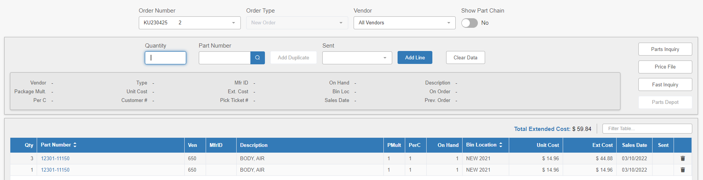
The order can then be receipted in Quick Receipts (QR), once the parts are received in.
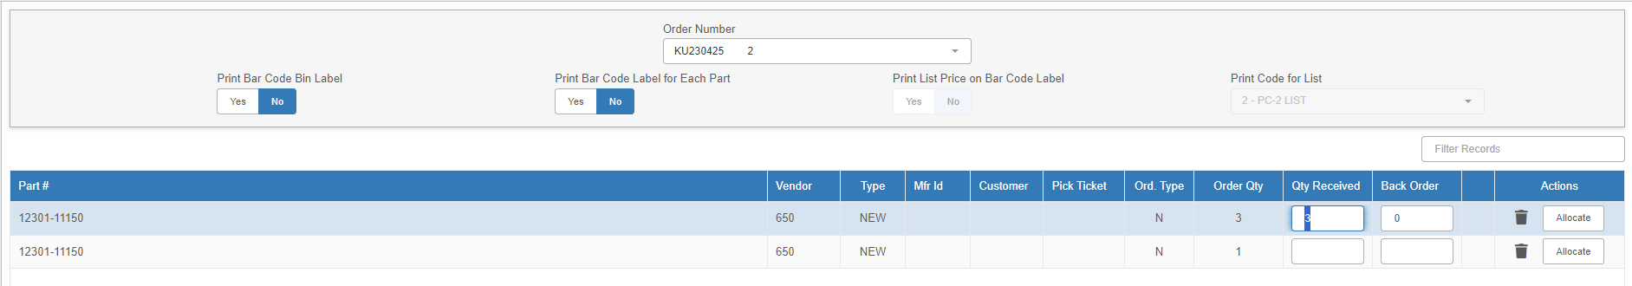
To summarize the order process:
- Go to Smart Supply. Confirm suggested order recommendations. Confirm the order by the cutoff time.
- The confirmed order will be generated at 2:00 local and sent to your HBS server
- At 2:15 HBS will receive the Order and create it in your Parts Order System.
- You will then be able to see the order in the following programs:
  - On Order Inquiry (OOI)
  - Quick Order Adjustments (QOA)
  - KubotaConnect (KUB)
- Adjust the order in QOA or use the Order Merge (CPOR) program to merge orders.
- Use KUB to submit the order officially to Kubota.

Redistribution (Transfers)
When a redistribution order is accepted in Smart Supply, it is sent over to HBS automatically, and will show up Inter-store Parts Transfers (ISPT).
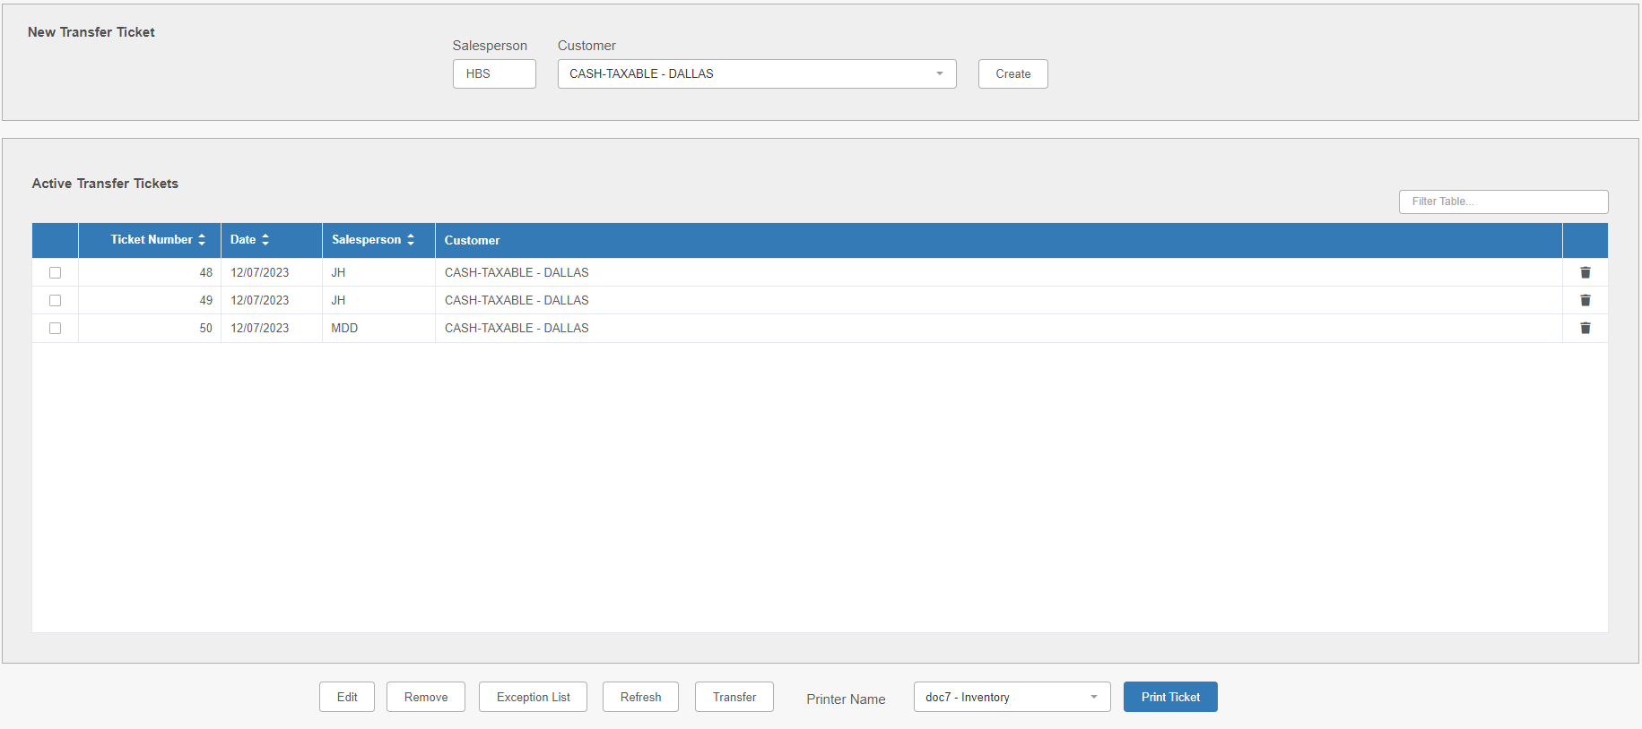
It will show up under the sending store, at which point the dealer will need to send it to the corresponding receiving store.

Demand/Sales History Exclusion
In Point of Sale (POS):
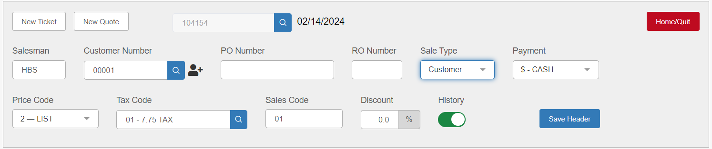
When creating a picking ticket in POS, you will see an option labeled “History” in the ticket header. If the switch is pushed to the right, causing the option to appear green, then sales history for the picking ticket is turned on.
To turn sales history off, click the switch to change its position to the left, causing it to turn grey:
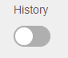
Click Save Header to save the setting.

In Repair Order Maintenance (ROM):
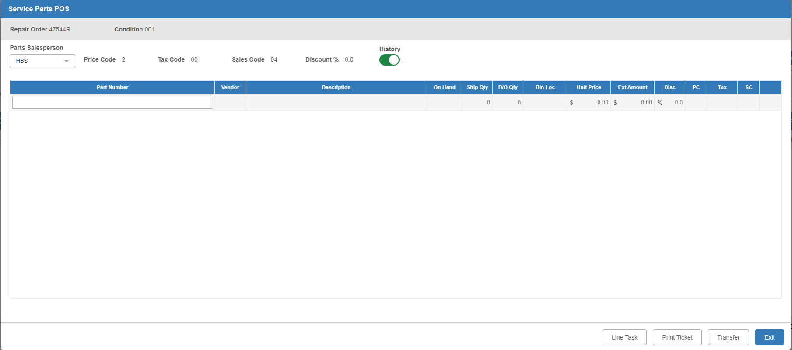
When creating a picking ticket in the Service Parts POS screen in ROM, you will see an option labeled “History” in the ticket header. If the switch is pushed to the right, causing the option to appear green, then sales history for the picking ticket is turned on.
To turn sales history off, click the switch to change its position to the left, causing it to turn grey:

The screen saves the option the moment you make the change, so if you click Exit and then reopen the modal, the sales history will still be turned off.

HBS Contact Information:
Email – support@hbssystems.com
Phone – 800-325-2252

